**CSS Grid**

1. Two-dimensional grid system
2. ﻿﻿CSS Grid Layout replaces float layout
3. ﻿﻿Fast & Clean Code
4. ﻿﻿No need for CSS frameworks
5. Property -> display : grid

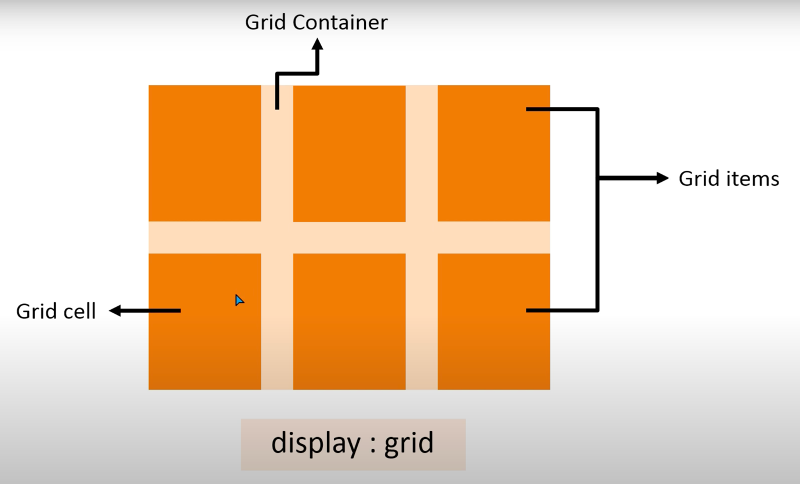

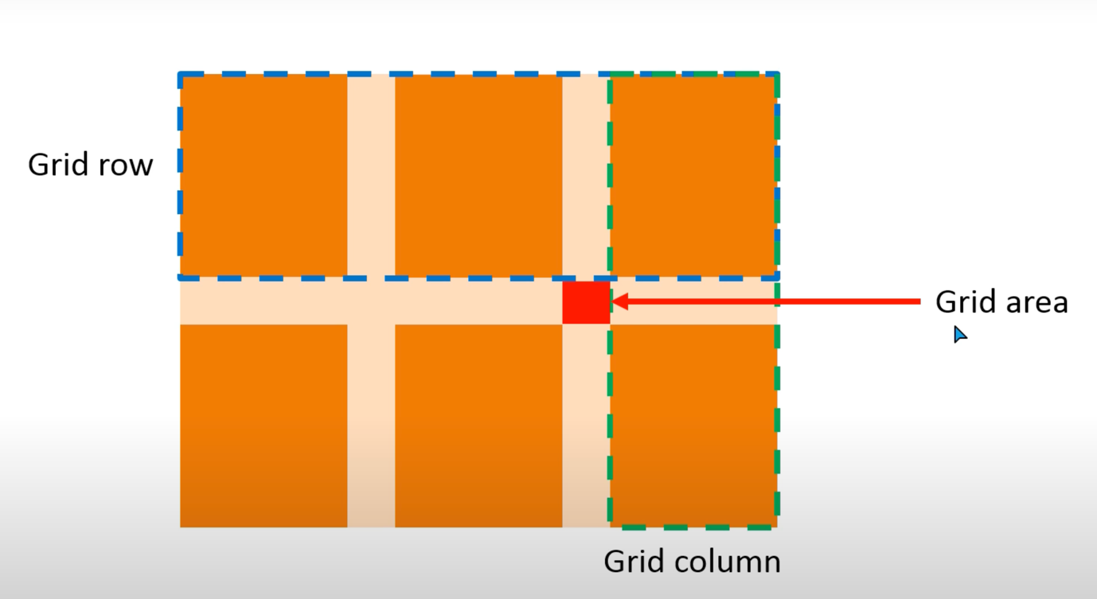

**Grid Properties**

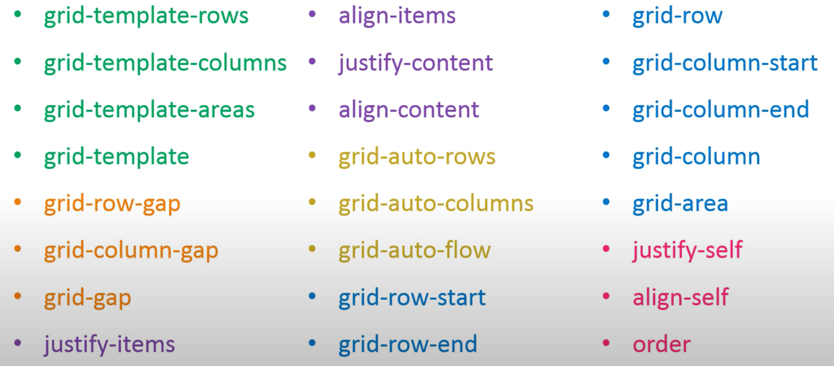

div.container

div.items.item$*6